Addition of Record using Text import
- Go to Database Manager and right Click on the screen.
- Choose Text import Wizard.
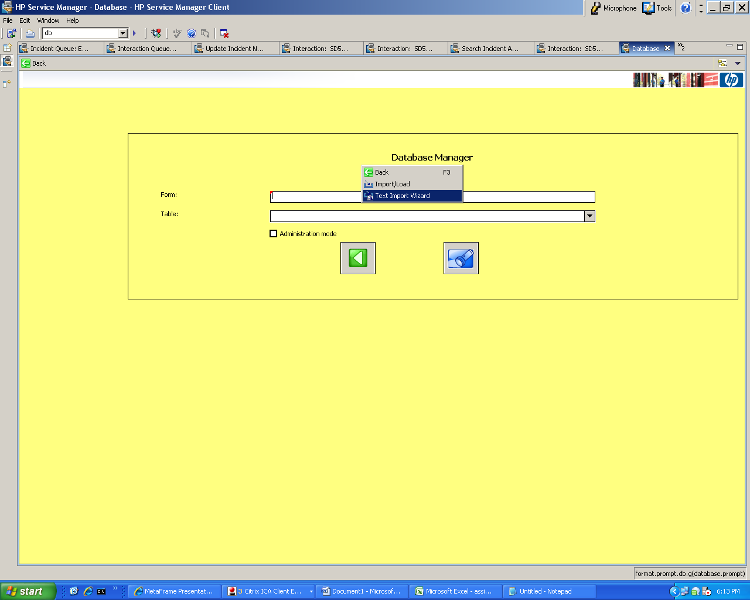
3. Select the file to be uploaded.
4. Destination table=assignment
5. File Type=winnt
6. Click Search
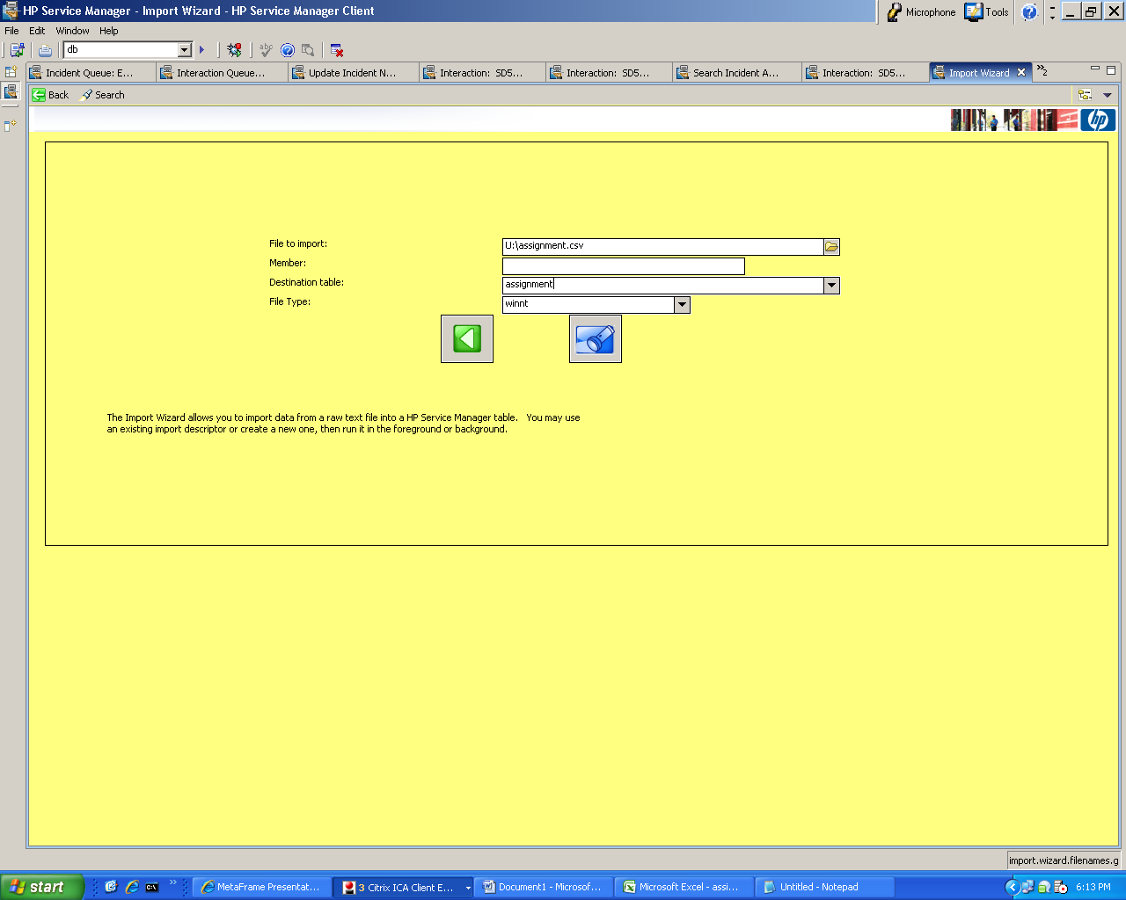
7. Select assignment.
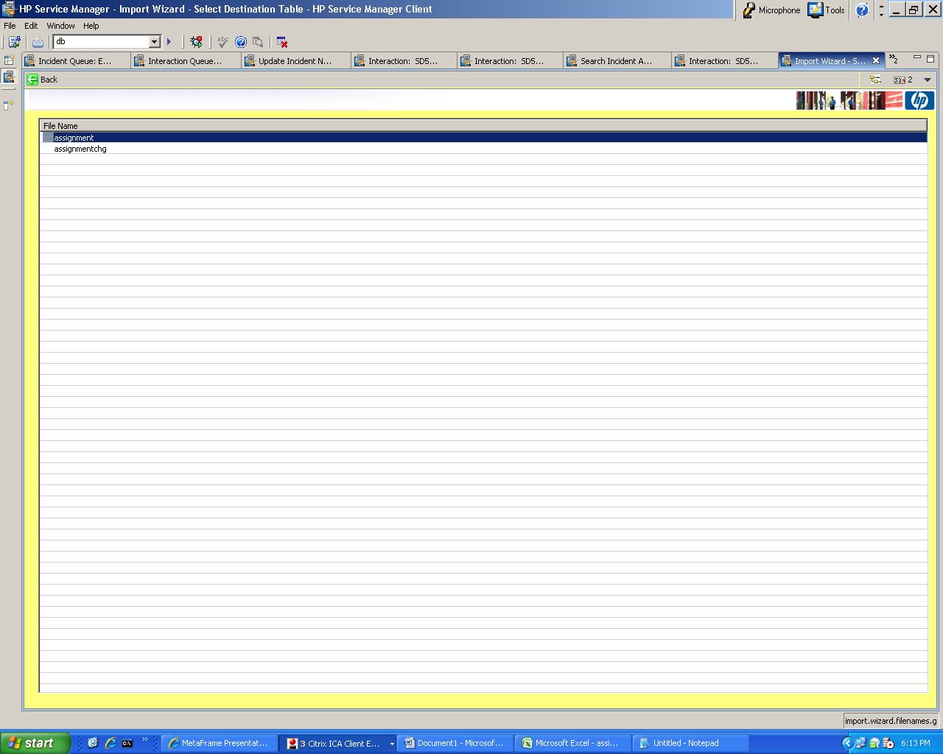
8. Choose tfs.load.assignment.groups.Emails2 and Doubleclick.
9. Click on Test and see the Test import Tab if the records are being fetched.

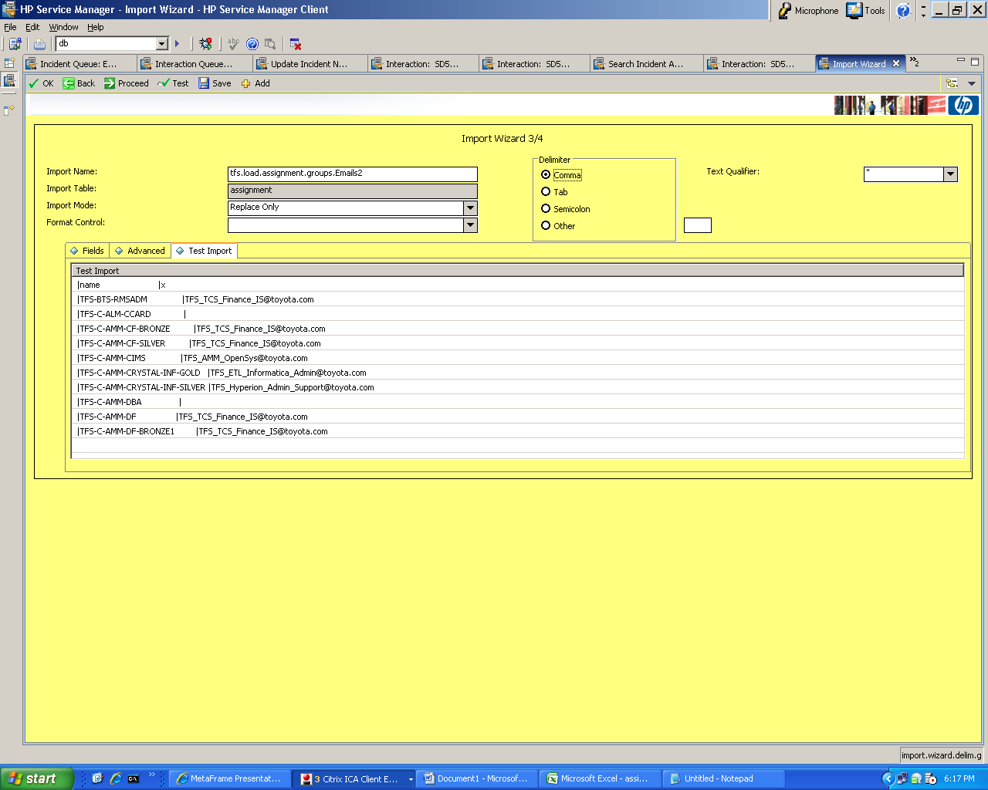
10. Click on proceed.
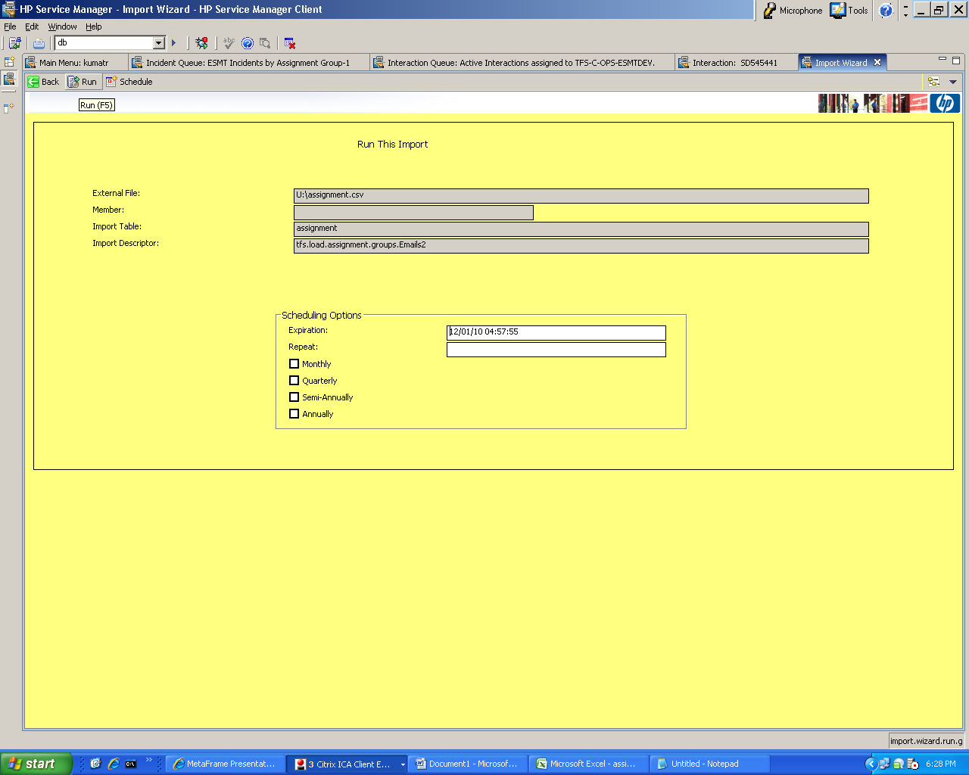

11. Click on Run.
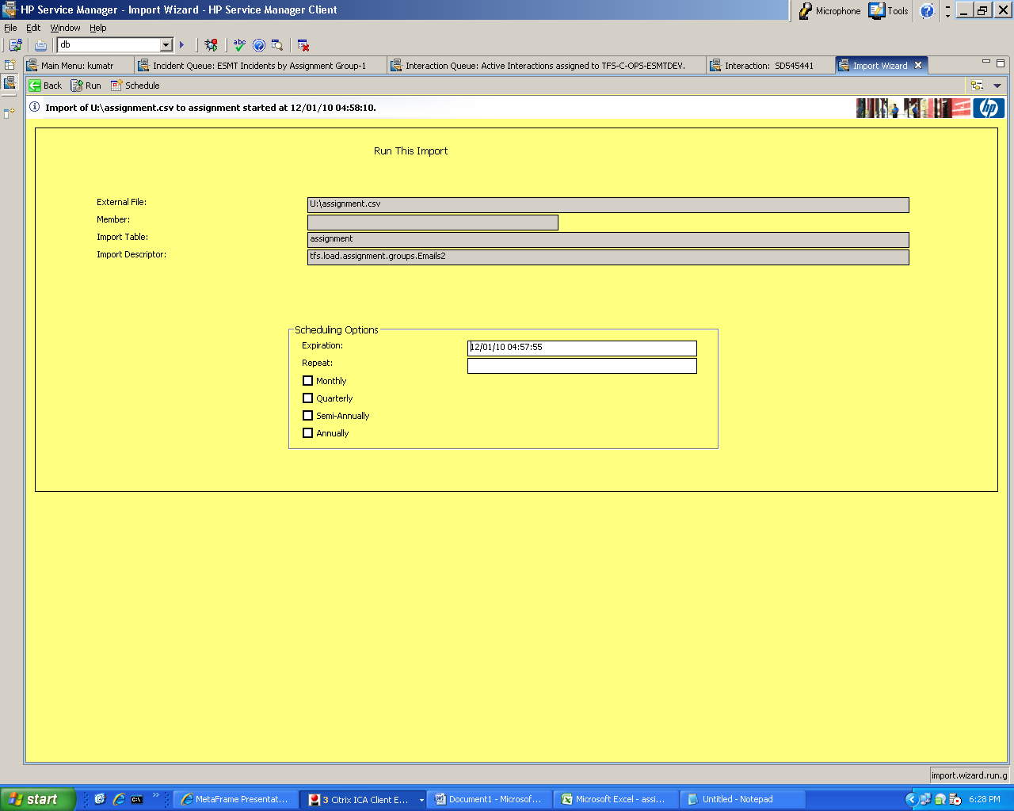

Note: if you find an error “duplicate header” then make sure the the txt file which u r adding has all the proper headings for all the columns

